To be able to create a FLP Plugin project in SAP WEB IDE, you need to enable the SAP Fiori Launchpad Extensibility extension.

[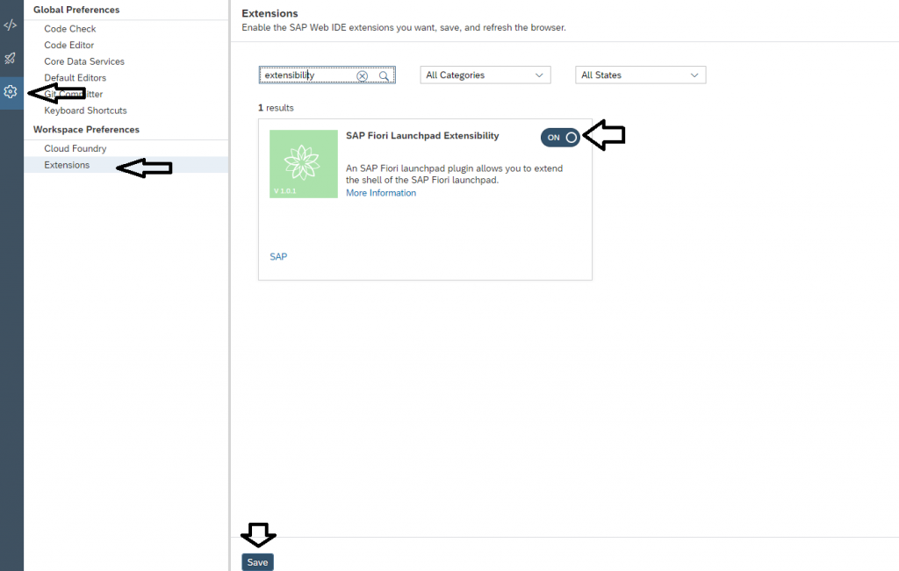](http://zyndanismanlik.com/wp-content/uploads/2019/10/1-enable_extension.png)

First, create a SAP FLP Plugin project.

[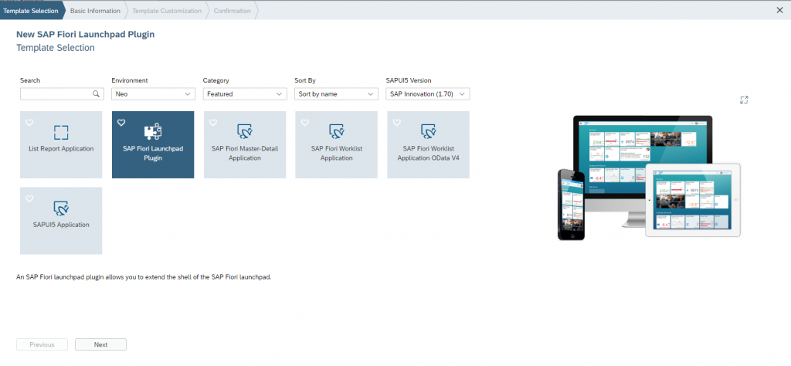](http://zyndanismanlik.com/wp-content/uploads/2019/10/2-template-selection.png)

Give your project a name

[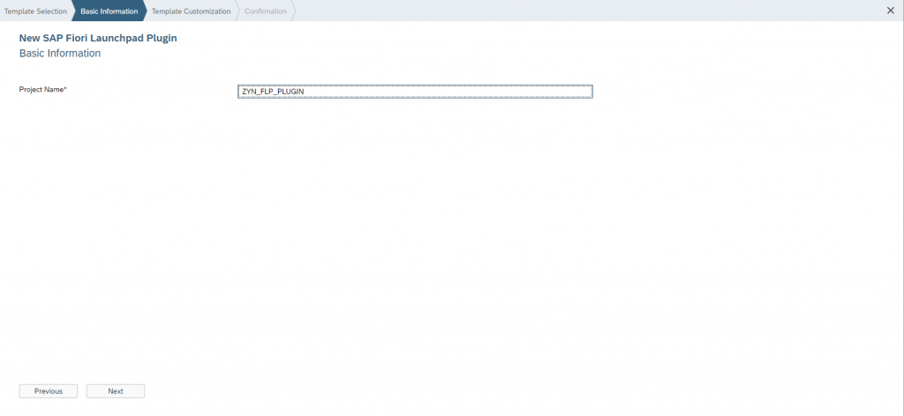](http://zyndanismanlik.com/wp-content/uploads/2019/10/3-basic-information.png)

Enter a plugin ID and title for your project and click Finish..

[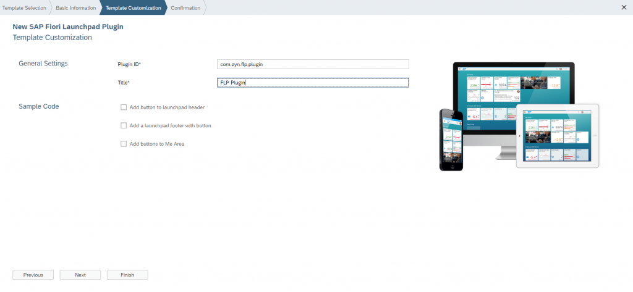](http://zyndanismanlik.com/wp-content/uploads/2019/10/4-template-customization.png)

Project structure

[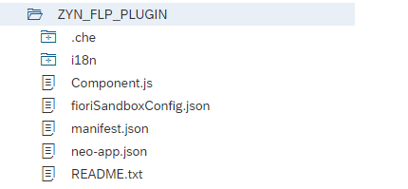](http://zyndanismanlik.com/wp-content/uploads/2019/10/5-project-structure.png)

Open Component.js and change Init method.To get the URL of user photo, you need to write an OData service..

[metin içeren bir resim

Açıklama otomatik olarak oluşturuldu](http://zyndanismanlik.com/wp-content/uploads/2019/10/me-area.png)

Deploy your project and create a Target Mapping like below..You can check [the article](http://zyndanismanlik.com/fiori-launchpad-cataloggrouprole-management/) for how to create Target Mapping and authorize users.

[metin içeren bir resim

Açıklama otomatik olarak oluşturuldu](http://zyndanismanlik.com/wp-content/uploads/2019/10/7-target_mapping.png)

After giving authorization of Target mapping to users..

[](http://zyndanismanlik.com/wp-content/uploads/2019/10/8-mission-completed.png)